Atoms and elements 2

1 Draw straight lines matching each term on the left with its definition on the right.
atom Negatively charged particle that orbits around the nucleus of an atom.
proton Pure substance made up of atoms of only one type.
neutron Central part of an atom, containing protons and neutrons.
electron Smallest piece of ordinary matter.
nucleus Positively charged sub-atomic particle.
element Organised chart of all known elements.
atomic number Atoms with the same number of protons but different numbers of neutrons.
mass number Columns of the periodic table.
atomic mass unit Metals found in group 1 of the periodic table.
isotopes The number of protons plus neutrons in the nucleus of an atom.
valence electrons Elements found in group 17 of the periodic table.
periods Used for measuring the mass of sub-atomic particles.
groups Electrons in the outermost shell.
alkali metals Rows of the periodic table.
alkaline earth metals The number of protons in the nucleus of an atom.
halogens Metals found in group 2 of the periodic table
periodic table Sub-atomic particle that has no charge.


2 Label the model of an atom shown below.

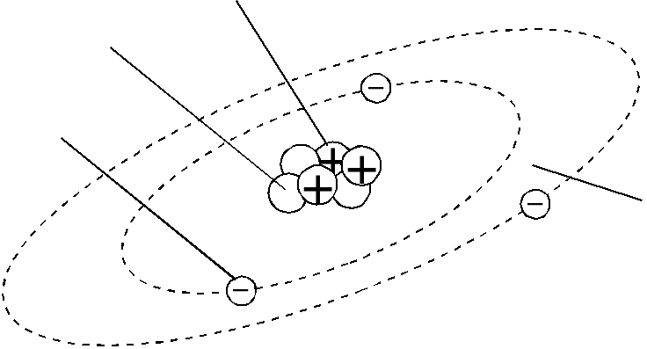

This model represents an atom of ______________________________
3 Complete this table.
Element | Symbol | Atomic number | Mass number | Number of protons | Number of electrons | Number of neutrons
helium |  | 2 |  |  |  | 2
 | N |  | 14 | 7
sodium |  |  | 23 |  |  | 12
chlorine |  |  | 35 |  | 17
 | Ca |  |  |  | 20 | 20

